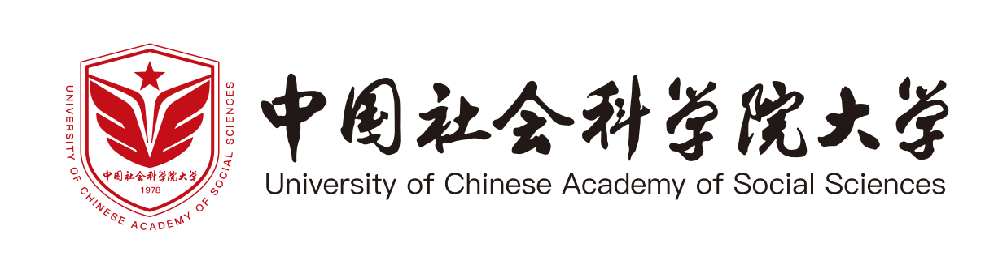

照 片
Photo

国际学生入学申请表
International Student Application Form (for English-taught Programs)

个人信息 Personal Information
中文姓名Chinese Name (If Any) |  |  |  |  | 英文姓  Surname |  |  |  | 英文名  Given Name
性别  Gender |  |  |  |  | 出生日期  Date of Birth |  |  |  | 出生地点  Place of Birth
国籍  Nationality |  |  |  |  | 职业 Occupation |  |  |  | 婚姻状况  Marital Status
宗教信仰  Religion |  |  |  |  | 母语  Native Language |  |  |  | 现居住国家  Country of Current Residence
护照信息 Passport & Visa
护照号码  Passport NO. |  |  |  |  |  |  | 护照有效期  Expiry Date of Passport
签证类别  Visa Type (If Any) |  |  |  |  |  |  | 签证有效期  Expiry Date of Visa
联系方式Contact Information
个人联系方式 Personal Contact
电话  Phone Number |  |  |  |  |  |  |  | 电子邮箱  E-mail
邮件联系地址  Mailing Address |  | （此地址用于邮寄录取材料/This address is valid for receiving admission materials）
家庭/紧急联系人联系方式 Home/Emergency Contact
联系人及关系  Full Name & Relationship |  |  |  |  |  |  | 联系电话Phone Number
住址
Home Address
在华联系人联系方式(若有) Contact Person in China (If Any)
联系人姓名  Full Name |  |  |  |  |  |  | 联系电话  Phone Number
联系人住址
Home Address
语言水平Language Proficiency
英语语言证书成绩  TOEFL/IELTS/GRE Score |  |  |  |  |  |  | 其它语言  Other Language
教育背景 Education Background (自本科阶段起from undergraduate program)
学校名称University Name |  |  |  |  |  | 开始时间  From (mm/yy) |  |  |  | 结束时间  To (mm/yy)
专业  Major |  |  |  |  |  | 获得的学位证书  Degree Obtained or to obtain
学校名称University Name |  |  |  |  |  | 开始时间  From (mm/yy) |  |  |  | 结束时间  To (mm/yy)
专业  Major |  |  |  |  |  | 获得的学位证书  Degree Obtained or to obtain
工作经历Work Experience
工作单位  Employer |  |  |  |  |  |  | 职位  Position
开始时间  From (mm/yy) |  |  |  |  |  |  | 结束时间  To (mm/yy)
工作单位  Employer |  |  |  |  |  |  | 职位  Position
开始时间  Time From (mm/yy) |  |  |  |  |  |  | 结束时间  Time To (mm/yy)
来华留学计划Study Plan at University of Chinese Academy of Social Sciences
学生类别  Student Category |  | □ 硕士研究生 Master Candidate □ 博士研究生PhD Candidate  □ 普通进修生 Visiting Student □ 高级进修生 Senior Visiting Student  □ 其他 Other
院/系/研究院  School/Department/Institute |  |  |  |  |  | 专业  Program/Major |  |  |  | 导师  Name of the Intended Supervisor
经费来源 Source of Financial Support
- 机构资助Institution Support □ 家庭资助 Family Support □ 自费Self-Support
声明Declaration
申请人保证/ I hereby affirm that:
- 申请表中所填写的内容和提供的材料真实无误；
All information and materials given in this form are true and correct;
- 在华期间，遵守中国的法律、法规，不从事任何危害中国社会秩序的、与本人来华学习身份不相符合的活动；
During my stay in China, I shall abide by the laws and decrees of the Chinese government, and will not participate in any activities which are deemed to be adverse to the social order in China and are inappropriate to the capacity as a student;
- 来华后到中国社会科学院大学（简称“大学”）报到注册，不无故要求变更学校和所学专业；
After arrival in China, I shall register at the University of Chinese Academy of Social Sciences (hereafter referred as the University), and will not request any changes in my field and institution of study without appropriate reasons;
- 在学期间，遵守学校的校纪、校规，全力投入学习和研究工作。尊重学校的教学安排；
During my study in China, I shall adhere to the rules and regulations of the University, and will concentrate on my studies and researches, and will follow the teaching programmes set up by the University;
- 按规定期限修完学业，按期回国，不无故在华滞留；
I shall return to my home country as soon as I complete my programme as scheduled at the University, and will not overstay my time of study in China without appropriate reasons or official approval;
- 如违反上述保证,将接受中国法律、法规或校纪、校规的惩处。
If I breach any above-mentioned self-declaration, I will accept the consequences of the Chinese laws and decrees and the rules and regulations of the University.
申请人签字  Applicant’s Signature |  |  |  |  |  |  | 日期  Date
注意事项Note
1. 申请人须用英文填写，其它文字或缺项填写的申请表可能致使申请无效。
This form should be completed in English only. An incomplete application or use of other languages may lead to unsuccessful application.
2. 申请人须按照《招生简章》要求，如实提交所有申请材料。
Applicants should truthfully prepare and provide all application materials as required in the Admission Guide.

招生联系办法Contact Information for Admissions
地址：中国北京市房山区长于大街11号 中国社会科学院大学 国际交流与合作处，邮编：102488
Address：International Exchange and Cooperation Department, University of Chinese Academy of Social Sciences,
No. 11 Changyu Street, Fangshan District, Beijing 102488, P.R. China
电话/Tel：+86-10-81360328
邮箱/E-mail：international@ucass.edu.cn
网址/Website: www.ucass.edu.cn/en，intl.ucass.edu.cn/lxskd1/ywxm.htm

